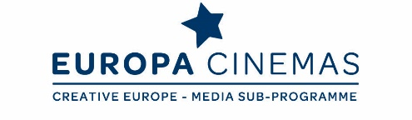

Dear Friends,
Europa Cinemas invites you to participate in a five day Lab as part of Sofia International Film Festival in Bulgaria.

Europa Cinemas Audience Development & Innovation Lab
"Making the Most of Your Resources to Build Audiences”
Sofia – Wednesday 14th to Sunday 18th March, 2018

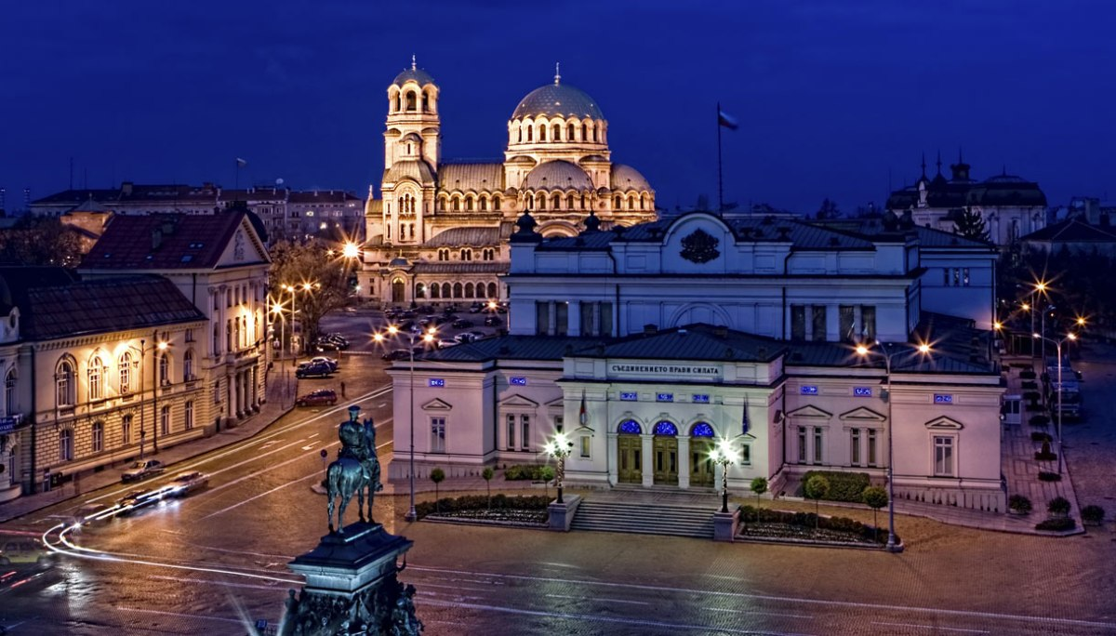

Join this lab to meet cinema practitioners from a diverse range of national contexts and exchange expertise in building audiences for films at the cinema and beyond. Led by Madeleine Probst (Vice-President of Europa Cinemas and Cinema Producer, Watershed, Bristol, United Kingdom) together with Javier Pachon (President of Cineciutat and Cinearte, Palma de Mallorca) and Erika Borsos (Programmer, Budapest Film, Budapest, Hungary), it is a great opportunity to share current thinking and practical solutions.
The focus will be on how to make the most of your biggest asset; the people within your organisation. We will explore ways of optimising resources in order to build more sustainable and dynamic relationships with audiences in a context of ever increasing abundance of content and platforms. Expect practical solutions to getting to know existing audiences better and overcoming barriers to engagement working towards more responsive and inclusive strategies to develop audiences for a diverse range of cinema experiences.

Open Slot sessions also give participants the space to pitch innovative ideas and approaches with their peers and/or identifying potential international collaborators for new projects. Headline topics will include:

• Building relationships; from community design to data analysis and customer relationship management
• Making the most of your resources from organisational development to involving volunteers and fundraising
• Better understanding barriers to engagement from pricing, accessibility to discoverability issues.
• Developing responsive and holistic communication and editorial strategies on and offline
• Closer co-operation and exchange of practice between European cinemas and distributors
• Learning about/from the Bulgarian context; exploring the challenges and opportunities for small cinemas in a small country, dominated by big players

IMPORTANT

This lab is open to all European exhibitors, members of Europa Cinemas network or not. The number of participants is limited to 30 people. Applications will be considered in the order they are received. However, priority will be given to exhibitors who never attended a Europa Cinemas Lab before and to exhibitors from Central and Eastern Europe and Balkan countries.

APPLICATION

Please fill in the online application form: https://form.jotformeu.com/EuropaCinemas/sofia-lab-application-form Please note that the application deadline is the 31st January 2018.

PRACTICAL INFORMATION
1. TRAVEL: all travel costs to and from Sofia are at your charge. When booking, please try to arrive before 2.30 pm on Wednesday 14th of March and to leave on Sunday 18th afternoon. Please do not make any reservation until your participation is officially confirmed by Europa Cinemas.
2. ACCOMMODATION: you need to be there from Wednesday 14th to Sunday 18th March (4 nights). Europa Cinemas and the Sofia International Film Festival will cover the cost of 3 nights (single room incl. breakfast) for one person per exhibition company, the fourth night being at your charge.
For your information, the single room rate will be approximately 70 euros (including breakfast and taxes). We will let you know the name of the hotel and more practical details very soon. Europa Cinemas will handle the hotel reservations and will also cover the cost of some of the meals.
3. ACCREDITATION: the Sofia International Film Festival will provide a festival accreditation (free of charge) which will give you access to all festival screenings.
4. LANGUAGE: the discussions will be held in English over the whole lab.
For more information on the seminar, do not hesitate to contact:
Fatima Djoumer, Head of International Relations and Events

Tel. +49 30 61 40 22 00, e-mail: fatim@djoumer.de

Sonia Ragone, Italy & Malta Coordinator

Tel. +33 (0)1 42 71 12 43, e-mail: sragone@europa-cinemas.org

Alexandre Tchernookov, Central and Eastern Europe Coordinator

Tel. +33 (0)1 42 71 83 62, e-mail: atchernookov@europa-cinemas.org

Thank you in advance for your kind attention and looking forward to seeing you in Sofia!

The Europa Cinemas Team

