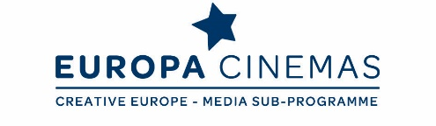

Dear Friends,
Europa Cinemas invites you to participate in a four day Lab as part of Sofia International Film Festival in Bulgaria.

Europa Cinemas Audience Development & Innovation Lab
"Building Relationships & Designing Experiences”
Sofia – Thursday 16th to Sunday 19th March, 2017

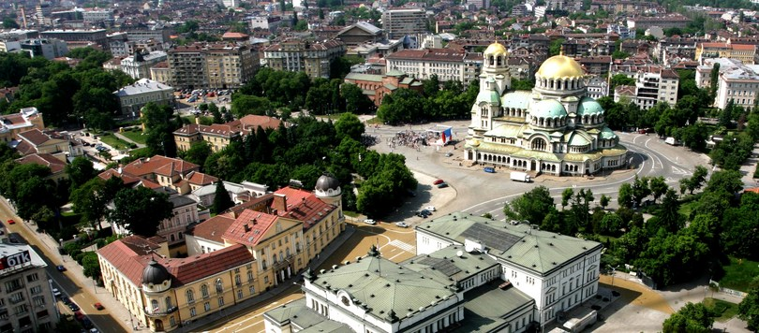

Join this lab to meet cinema professionals from a diverse range of national contexts and exchange practice based expertise and experiences of dynamic new approaches to audience development. Led by Madeleine Probst (Vice-President of Europa Cinemas and Cinema Producer, Watershed, Bristol, United Kingdom) together with Hrvoje Laurenta (Manager, Kino Europa in Zagreb, Croatia, Europa Cinemas Awards 2016 – Best Programming winner) and Sylvain Chevreton (Young Audience Coordinator, Le Méliès in Saint-Etienne, France), it is an opportunity to explore current thinking and practical solutions.
The focus will be on approaches to designing cinema going experiences that resonate with audiences and to building sustainable and responsive relationships in a context of ever increasing abundance of content and platforms. We will also explore the potential for more fine-tuned and granular ways of getting to know audiences and reaching out to new communities; and how such insights might lead to more responsive communication strategies and deeper audience engagement. Getting the balance between responding to what audiences tell you they think they want and developing curatorial brands that audiences trust is a growing area for debate which presents challenges and opportunities for the sector.

As Bobby Allen (MUBI) recently put it at the UK’s This Way Up Conference: "No algorithm has ever laughed or cried at a film or put a film poster up on its wall – film watching is a human experience." Talking of human experience, the lab will offer insights in developing our biggest asset, our people and their capacity to lead and collaborate within organisations and beyond. Open Slot sessions also give participants the space to pitch innovative ideas and approaches with their peers and/or identifying potential international collaborators for new projects. Headline topics will include:
- Building relationships; from community design and brand-building to customer relationship management
- Leading the dance with data; covering a range of approaches to audience data capture, benchmarking and evaluation and practical ways of using data-driven insights to inform and improve your practice
- Designing expected and unexpected experiences for existing and new audiences; navigating the “abundance” of content and multiplicity of platforms through curation and editorialisation and taking “cultural risks” with audiences
- Developing people’s capacity to lead and collaborate within your organisation and beyond; from your staff and partners to younger generations of creatives and audiences
- Learning about/from the Bulgarian context; exploring the challenges and opportunities for small cinemas in a small country, dominated by big market players

IMPORTANT

This lab is open to all European exhibitors, members of Europa Cinemas network or not. The number of participants is limited to 30 people. Applications will be considered in the order they are received. However, priority will be given to exhibitors who never attended a Europa Cinemas Lab before and to exhibitors from Central and Eastern Europe and Balkan countries.

APPLICATION

Please find enclosed the application form. It is to be returned by e-mail by Wednesday, 2nd February 2017 at the latest to: sragone@europa-cinemas.org

PRACTICAL INFORMATION
1. TRAVEL: all travel costs to and from Sofia are at your charge. When booking, please try to arrive before 2.30 pm on Thursday 16th of March and to leave on Sunday 19th afternoon. Please do not make any reservation until your participation is officially confirmed by Europa Cinemas.
2. ACCOMMODATION: you need to be there from Thursday 16th to Sunday 19th March (3 nights). Europa Cinemas and the Sofia International Film Festival will cover the cost of 2 nights (single room incl. breakfast) for one person per exhibition company, the third night being at your charge.
The hotel where you will be accommodated is called Central Park Hotel Sofia (106 Vitosha Blvd., 1463 Sofia). For your information, the single room rate will be 50 euros (including breakfast). Europa Cinemas will handle the hotel reservations and will also cover the cost of some of the meals.
3. ACCREDITATION: the Sofia International Film Festival will provide a festival accreditation (free of charge) which will give you access to all festival screenings.
4. LANGUAGE: the discussions will be held in English over the whole seminar.
For more information on the seminar, do not hesitate to contact:
Fatima Djoumer, Head of International Relations and Events

Tel. +49 30 61 40 22 00, e-mail: fatim@djoumer.de

Sonia Ragone, Italy & Malta Coordinator - Young Audience Coordinator

Tel. +33 (0)1 42 71 12 43, e-mail: sragone@europa-cinemas.org

Alexandre Tchernookov, Central and Eastern Europe Coordinator

Tel. +33 (0)1 42 71 83 62, e-mail: atchernookov@europa-cinemas.org

Thank you in advance for your kind attention and looking forward to seeing you in Sofia!

The Europa Cinemas Team

