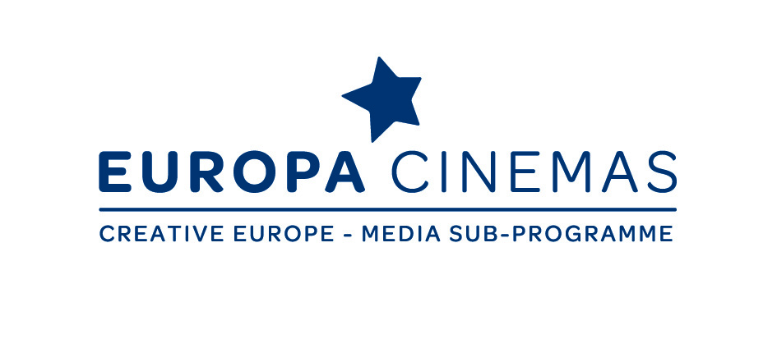

Europa Cinemas Audience Development & Innovation Lab

Sofia, from Thursday 16th to Sunday 19th March 2017

APPLICATION FORM

To be returned before Thursday 2th February 2017 by email to
sragone@europa-cinemas.org

APPLICANT DETAILS
SURNAME FIRST NAME
POSITION AT THE CINEMA
SPOKEN LANGUAGES
E-MAIL MOBILE PHONE

CINEMA DETAILS
CINEMA(S) AND NUMBER OF SCREENS
COMPANY
COMPANY’S ADDRESS
ZIP CODE TOWN COUNTRY
TELEPHONE
MEMBER OF EUROPA CINEMAS: YES/NO

What are you hoping to achieve by taking part in this workshop?

Which are the fields in which you feel you need to improve?

Data management
Building relationships with the audience
Curation, programming, editorialisation
Managing staff and people’s capacity
Other: …………

Please explain briefly what are your challenges in relation to the boxes you ticked above.

Please write a short summary of your most successful or most original project.

Why do you think it worked so well (marketing, partnerships, social media, programming choices, etc.)?

Open slot session: please present in a few lines a project realised or to be realised that you would like to pitch

PLEASE CONFIRM THE POINTS BELOW

I will be able to attend the whole lab, from Thursday 16th to Sunday 19th of March 2017
I have understood that this application does not grant me a registration to the lab

